**Case Study**

**Emp Name: Mayank Malhotra**

**Emp Id: INMMLF**

**Github Repo:** [mayank29malhotra/Shell_Case_Study (github.com)](https://github.com/mayank29malhotra/Shell_Case_Study)

**SDLC, Agile and Software Testing**

1. Created Azure Virtual Machine:

Azure VM Deployed:

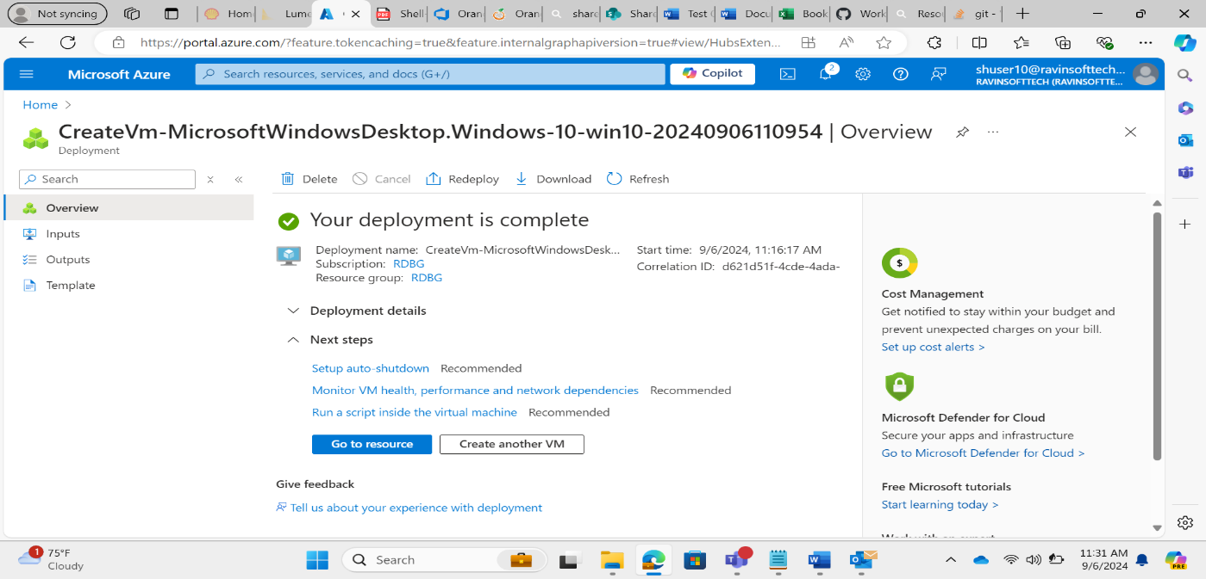

1. Created a project on the Azure Devops:

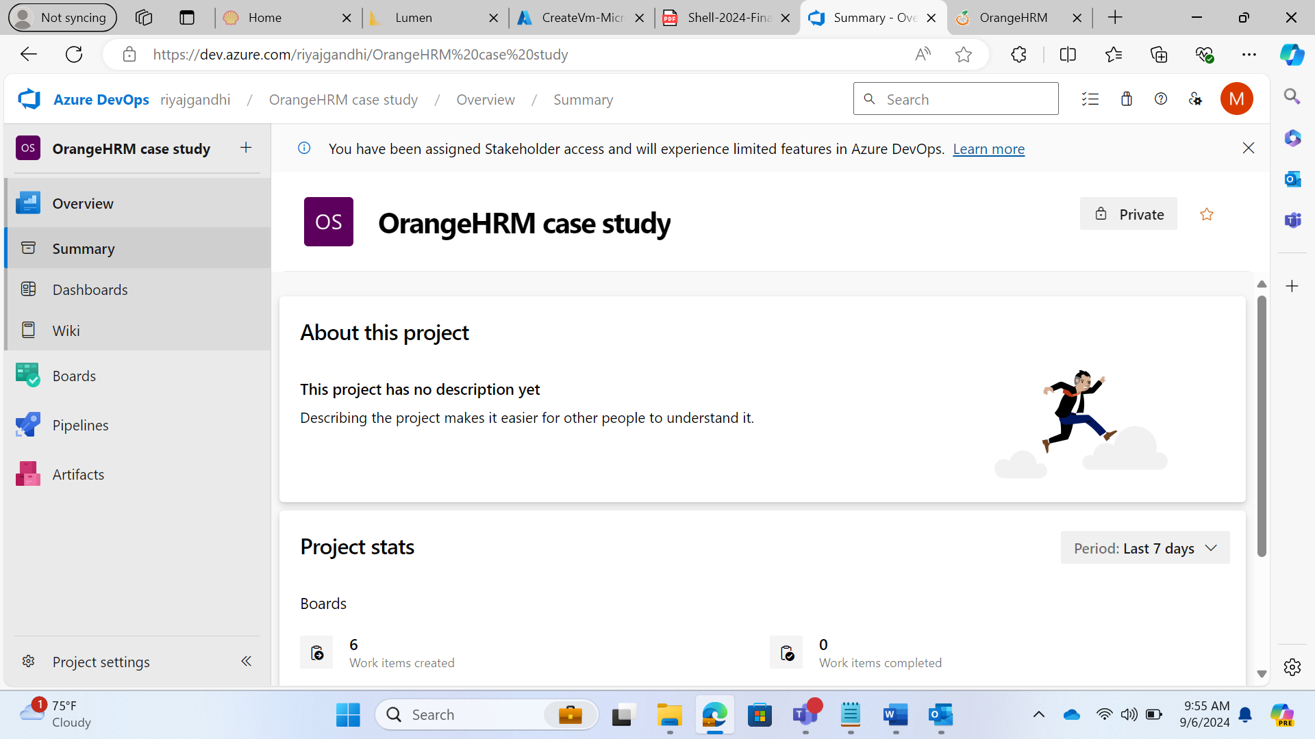

1. Created 5 User Stories in the Product Backlog

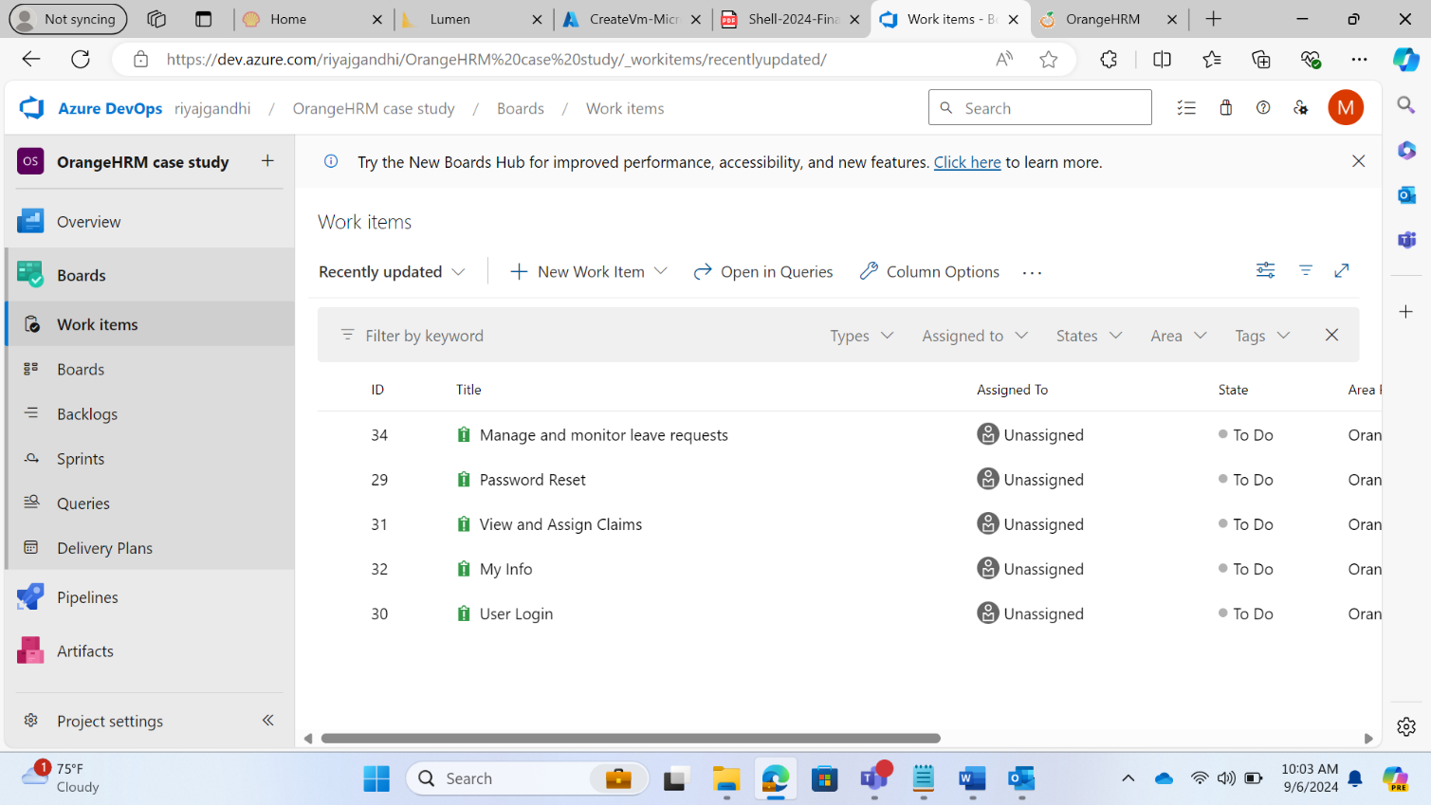

1. Created Sprint Backlog with all the 5 User stories and created the Tasks.

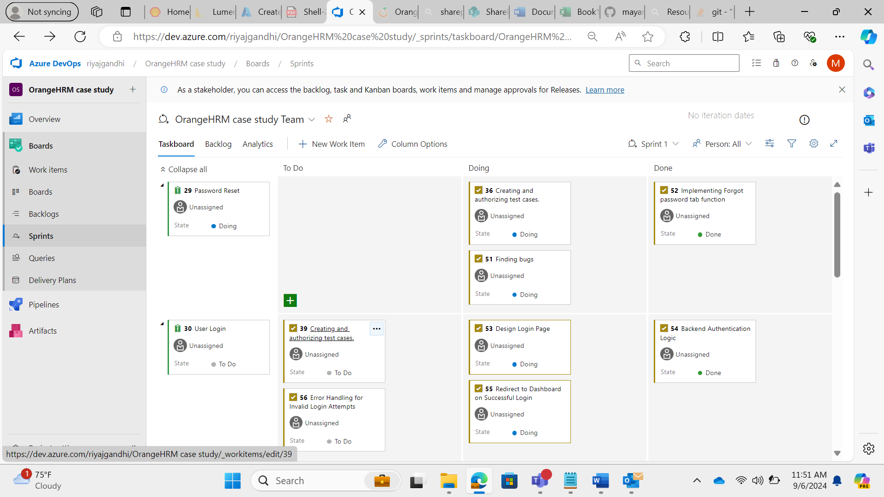

User Stories:

1. Password Reset Module:

As a user, I want to reset the password if I forget it so that I can regain access to my account.

**Acceptance criteria:**

-User clicks "forgot your password" and is redirected to reset password page.

-User receives an email with reset instruction.

-User is able to reset their password and log in with the new password.

1. User Login Module:

As a User, I want to log in to the system using my username and password so that I can access my HR management dashboard.

**Acceptance Criteria:**

- User can enter valid username and password.

- User is successfully logged in when credentials are correct.

- Error message is displayed for invalid credentials.

1. View and Assign Claims:

As a user I should be able to view and assign new claims to employees so that I can effectively manage employee claims.

**Acceptance Criteria:**

1. The HR Manager can log in to the system.
2. The HR Manager can navigate to the claims section.
3. The HR Manager can view a list of all pending claims.
4. The HR Manager can assign claims to specific employees.
5. The system confirms the assignment of claims.
6. My Info Tab:

As a user, when I login to Orange HRM, and go to "My Info" tab, I should be able to to view my previously filled information and I should be able to edit the fields to update my personal information and save it.

**Acceptance Criteria:**

* User should be able to view previous information.
* User should be able to update any field of the form.
* The updates changes must get saved.
* The changes must be reflected across the profile.

1. Manage and Monitor leave Request:

As an admin user, I want to utilize the different tabs in the leave section (Apply, My Leave, Entitlements, Reports, Configure, leave list, assign leave) so that I can effectively manage and monitor leave activities across the organization.   
  
**Acceptance Criteria:**

* Apply tab - admin can apply for leave for himself/herself and that leave will be recorded.
* My leave tab - admin can view his/her leave history, including past and pending leave requests. The leave history can be filtered by date range, leave status and leave type.
* Reports tab - admin can generate reports on leave statistics, such as total leaves taken, leave balances, and leave types by department or individual. Reports can be exported as pdfs.
* Configure tab - admin can configure leave period, leave types, work weeks and holidays.
* Leave list tab - admin can view a comprehensive view of all the leave requests within the organization, sorted by status (rejected, cancelled, pending approval, scheduled, taken), leave type, employee name and the sub-unit.
* Assign leave tab - admin can assign leaves directly to an employee, selecting the name of an employee, leave type and date. A comment section should also be present.

1. Creating the Test Cases for the user stories:

**Test#001: Scenario: Successful login with valid credentials.**

Given I am on the OrangeHRM login page.

When I enter "Admin" as the username

And I enter "admin123" as the password.

And I click on the "Login" button.

Then I should be redirected to the OrangeHRM dashboard

And I should see the welcome message on the dashboard.

**Test#002: Scenario: Unsuccessful login with invalid password.**

Given I am on the OrangeHRM login page.

When I enter "Admin" as the username.

And I enter "wrongPassword" as the password.

And I click on the "Login" button.

Then I should see an error message "Invalid credentials"

And I should remain on the login page.

**Test#003: Scenario: Unsuccessful login with empty username.**

Given I am on the OrangeHRM login page.

When I leave the username field blank

And I enter "admin123" as the password.

And I click on the "Login" button.

Then I should see an error message "Username cannot be empty"

And I should remain on the login page.

**Test#004: Scenario: Unsuccessful login with empty password.**

Given I am on the OrangeHRM login page.

When I enter "Admin" as the username

And I leave the password field blank.

And I click on the "Login" button.

Then I should see an error message "Password cannot be empty"

And I should remain on the login page.

**Test#005: Scenario: Clicking "Forgot Your Password" redirects to forgot password screen.**

Given I am on the OrangeHRM login page.

When I click on the "Forgot your password?" link

Then I should be redirected to the OrangeHRM password reset page

And I should see a form to enter the username or email for password recovery.

**Test#006: Scenario: View all claims.**

Given I am logged into the system as an admin.

When I navigate to the "Claims" section

And I click on "Employee Claims".

Then I should see a list of all claims

**Test#007: Scenario: View claim details.**

Given I am logged into the system as an admin.

And a list of claims is available.

When I click on a specific employee claim

Then I should see the detailed information of the selected claim

**Test#008: Scenario: Assign claim to an employee.**

Given I am logged into the system as an admin.

And a list of unassigned claims is available.

When I select an unassigned claim

And I click on "Assign Claim".

And I select an employee from the list.

And I click "Assign".

Then the claim should be assigned to the selected employee

And the status should be updated accordingly.

**Test#009: Scenario: Filter claims by status.**

Given I am logged into the system as an admin.

And a list of claims is available.

When I select a status filter "Pending"

Then I should see only the claims with the status "Pending"

**Test#010: Scenario: Search claims by employee name.**

Given I am logged into the system as an admin.

And a list of claims is available.

When I enter an employee name in the search bar

And I click on the search icon.

Then I should see the claims related to the entered employee name

**Test#011: Scenario: Search claims by reference ID.**

Given I am logged into the system as an admin.

And a list of claims is available.

When I enter a reference ID in the search bar

And I click on the search icon.

Then I should see the claims related to the entered reference ID

**Test#012: Scenario: Search claims by date range.**

Given I am logged into the system as an admin.

And a list of claims is available.

When I select the "From Date" and "To Date" fields

And I enter the desired date range.

And I click on the search icon.

Then I should see the claims within the specified date range

**Test#013: Scenario: Search claims by event name.**

Given I am logged into the system as an admin.

And a list of claims is available.

When I enter an event name in the search bar

And I click on the search icon.

Then I should see the claims related to the entered event name

**Test#014: Scenario: Accessing the My Info tab.**

Given the user is logged in to the website.

When the user navigates to the "My Info" tab

Then the dashboard should display personal details, contact details, emergency contact, jobs, salary, and other information related to the user in the form of a vertical dashboard.

**Test#015: Scenario: Viewing Personal Detail**

Given the user is on the "My Info" tab on the website.

When the user selects the "Personal Details" tab.

Then the personal details form should display the user's current personal information as prefilled fields on the form

**Test#016: Scenario: Updating Personal Details**

Given the user is on the "Personal Details" form in the My Info section.

When the user updates the personal information with previously filled data

And submits the form.

Then the updated personal information should be saved successfully

And a confirmation message should be displayed.

And the same should be reflected across the system.

**Test#017: Scenario: Viewing Contact Details**

Given the user is on the "My Info" tab.

When the user selects the "Contact Details" tab

Then the contact details form should display the user's current contact information

**Test#018: Scenario: Updating Contact Details**

Given the user is on the "Contact Details" form.

When the user updates the contact information with valid data

And submits the form.

Then the updated contact information should be saved successfully

And a confirmation message should be displayed.

**Test#019: Scenario: Filling the Contact Details form.**

Given the user is on the "Contact Details" tab.

When the user fills the fields, such as contact number.

Then the form should accept 10-digit numeric value only.

**Test#020: Scenario: Filling the personal details form.**

Given the user is on the "Personal Details" tab.

When the user fills the fields such as Name, Driver License, Employee ID etc.

Then the form should accept valid input for each accordingly

**Test#021: Scenario: Admin successfully applies for leave.**

Given the admin user navigates to leave section from the side-menu navbar.

When the admin navigates to the 'Apply' tab

And selects a leave type, start date, end date and enters a reason.

And clicks on the 'Apply' button.

Then the leave request should be successfully recorded in the system

And the leave should appear under the 'My Leaves' tab.

**Test#022: Scenario: Admin views leave history with filtering options.**

Given the admin user navigates to leave section from the side-menu navbar.

When the admin navigates to the 'My leaves' tab.

And applies filters by date range, leave status, and leave type.

Then the filtered leave history should be displayed correctly

**Test#023: Scenario: Admin generates, and exports leave reports.**

Given the admin user navigates to leave section from the side-menu navbar.

When the admin navigates to the 'Reports' tab

And generates a report based on leave type, leave status, department or employee.

And exports the report as a PDF.

Then the report should be generated correctly and available for download as a PDF

**Test#024: Scenario: Admin views and filters leave reports.**

Given the admin user navigates to leave section from the side-menu navbar.

When the admin navigates to the 'Leave list' tab

And sorts the leave requests by status, leave type, employee name or sub-unit.

Then the leave requests should be displayed according to the selected filters and sorting options

**Test#025: Scenario: Admin attempts to apply leave for past dates.**

Given the admin user navigates to leave section from the side-menu navbar.

When the Admin navigates to the "Apply" tab

And selects a past date for leave.

Then an error message should be displayed

And the leave request should not be submitted.

**Test#026: Scenario: Admin views pending leave requests.**

Given the admin user navigates to leave section from the side-menu navbar.

When the Admin navigates to the "Leave List" tab

And filters by "Pending Approval" status

Then all pending leave requests should be displayed accurately

**Test#027: Scenario: Successfully request a password reset link.**

Given the user is on the "forgot password page".

When the user enters a registered email address "[user@example.com](mailto:user@example.com)"

And user clicks the submit button.

Then the system should send a password reset link to mail address and the system should display confirmation message password reset link sent

**Test#028: Scenario: Request password reset with an unregistered email address.**

Given the user is on the "Forgot Password" page.

When the user enters an unregistered email address "[unknown@example.com](mailto:unknown@example.com)"

And the user clicks the "Submit" button.

Then the system should display an error message "Email address is not registered."

**Test#029: Scenario: Successfully reset password using the reset link.**

Given the user has received a password reset link at "[user@example.com](mailto:user@example.com)"

And the user clicks the password reset link.

When the user enters a new password "NewPassword123" and confirms it

And the user clicks the "Submit" button.

Then the system should display a confirmation message "Your password has been successfully reset."

And the user should be able to log in with the new password.

**Test#030: Scenario: Reset password with mismatched confirmation.**

Given the user has received a password reset link at "[user@example.com](mailto:user@example.com)"

And the user clicks the password reset link.

When the user enters a new password "NewPassword123" and confirms it with "DifferentPassword123"

And the user clicks the "Submit" button.

Then the system should display an error message "Passwords do not match."

**Test#031: Scenario: Successfully reset password using the reset link**

Given the user has received a password reset link at "[user@example.com](mailto:user@example.com)"

And the user clicks the password reset link

When the user enters a new password "NewPassword123" and confirms it

And the user clicks the "Submit" button

Then the system should display a confirmation message "Your password has been successfully reset."

And the user should be able to log in with the new password

**Test#032: Scenario: Reset password with mismatched confirmation**

Given the user has received a password reset link at "[user@example.com](mailto:user@example.com)"

And the user clicks the password reset link

When the user enters a new password "NewPassword123" and confirms it with "DifferentPassword123"

And the user clicks the "Submit" button

Then the system should display an error message "Passwords do not match."

**TestCase#033: Scenario: In Contact details, email should be verified.**

Given the user is on My Info Tab, in contact details,

When the user attempts to enter email,

Then the email address validity should be checked.

1. Done Functional (Regression) Testing for all the Test Cases and created the Bug Report:

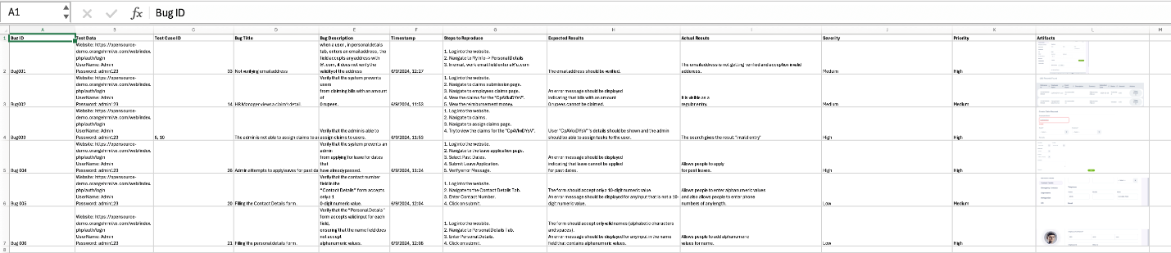

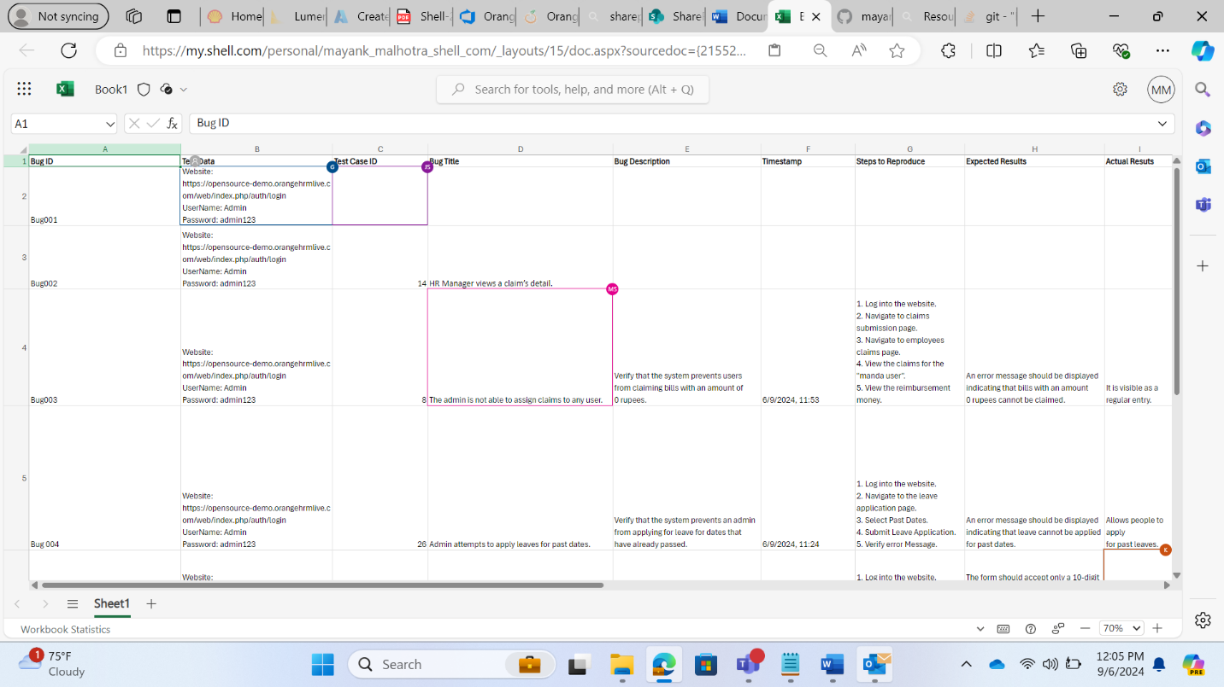

1. Requirement traceability Matrix:



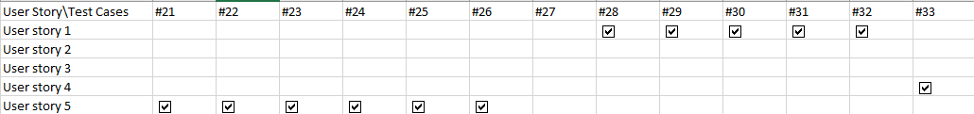

**Implementing the CI/CD Pipeline using GitHub Actions**

1. Created a new Repository.

1. Created the Java code for a Simple Calculator

1. Created the pom.xml file and added it on the Repository.

1. Created GitHub-Actions pipeline for Java with Maven
2. Changed the settings of the Repository to give the Read/Write access.

1. Done some changes in .java file and committed it resulted to automatically building and passed.